Assignment 1

* Create your first S3 bucket. Do the following:

1) Upload an object to your bucket.

2) Download an object

3) Copy your object to a folder

4) Delete your objects and bucket

Steps to create S3 Bucket:

1. First click on create Bucket.

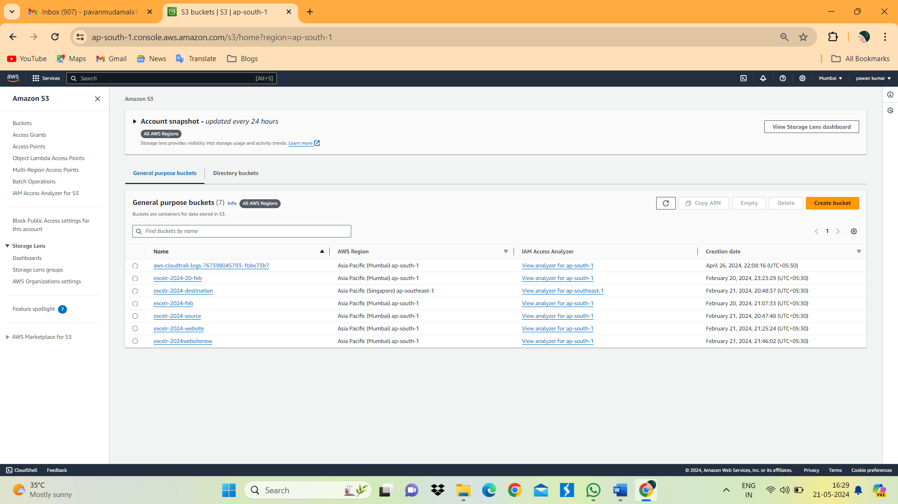

1. Give Bucket name as bucket-storage 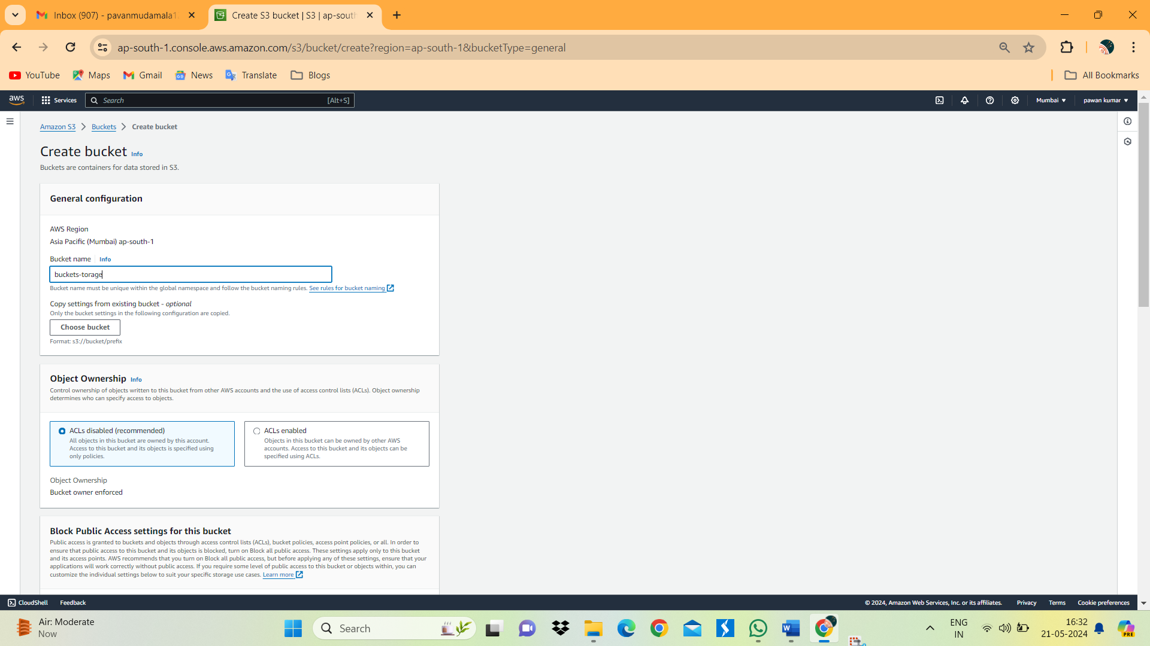
2. Click on create bucket.

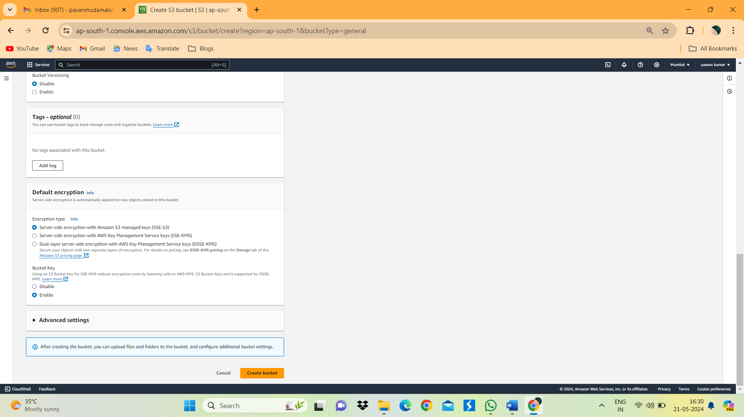

4.Below image we can see bucket storage on image.

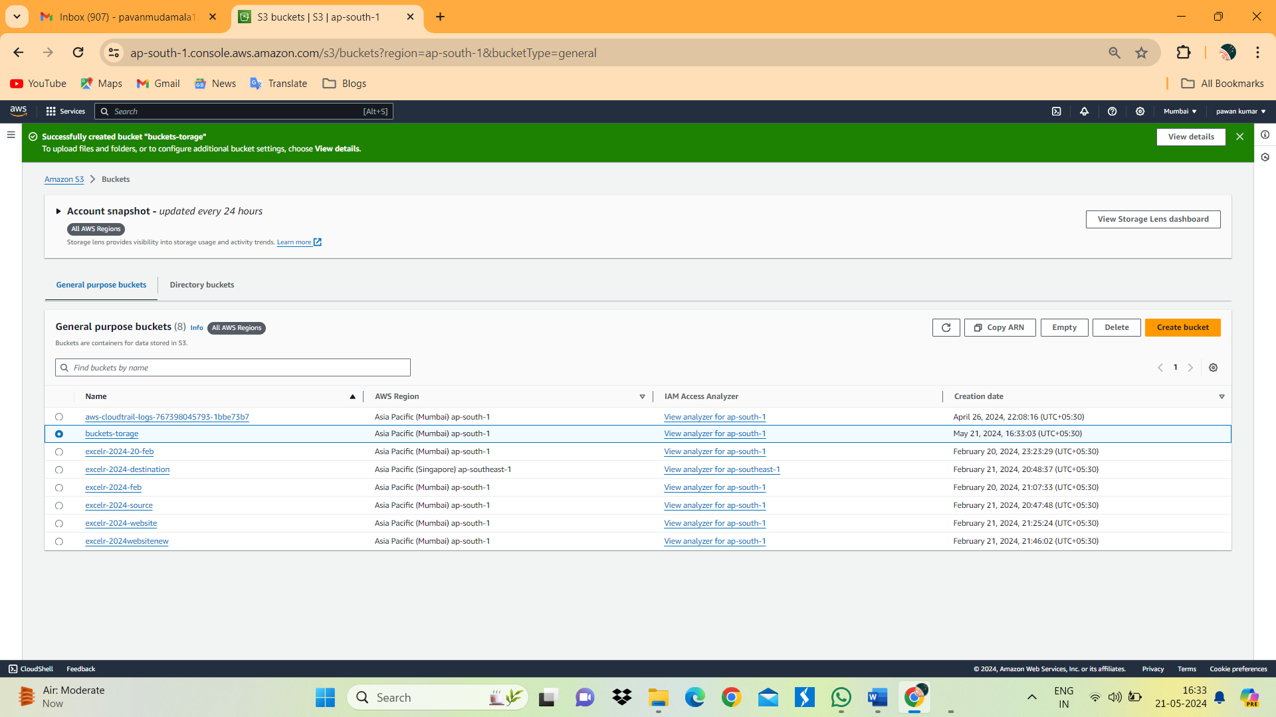

1. Open the bucket and click on upload option.

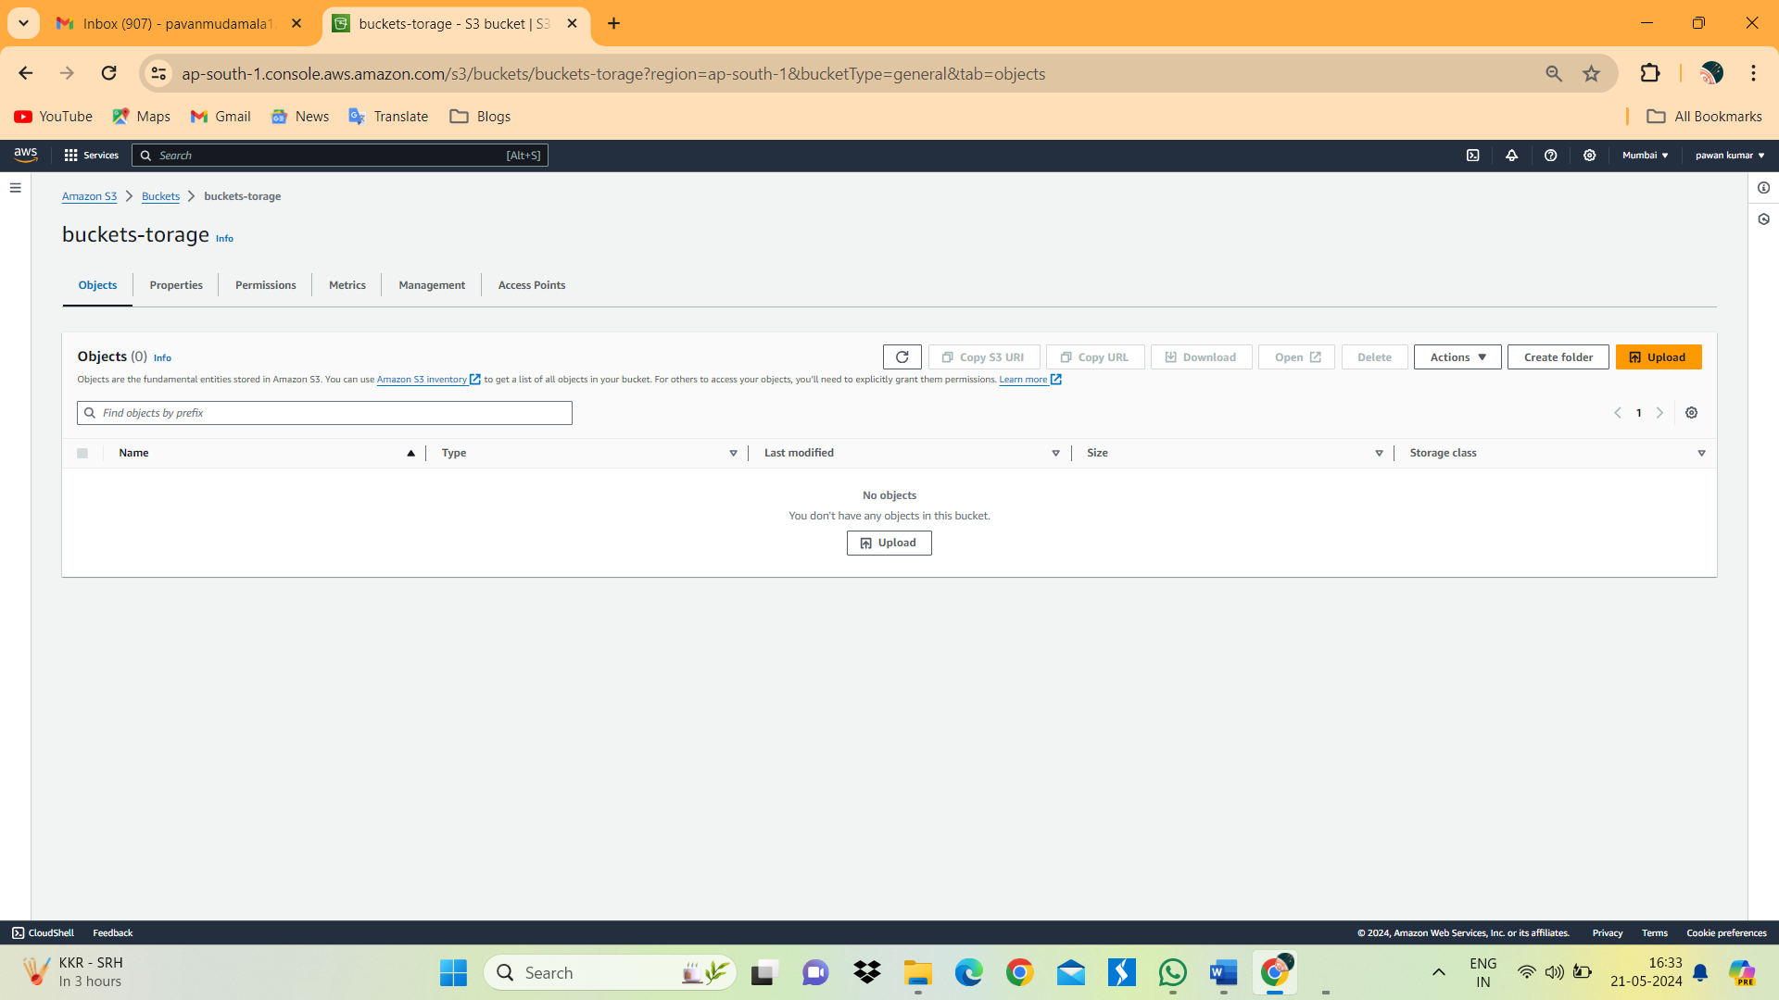

1. Click on Add File.

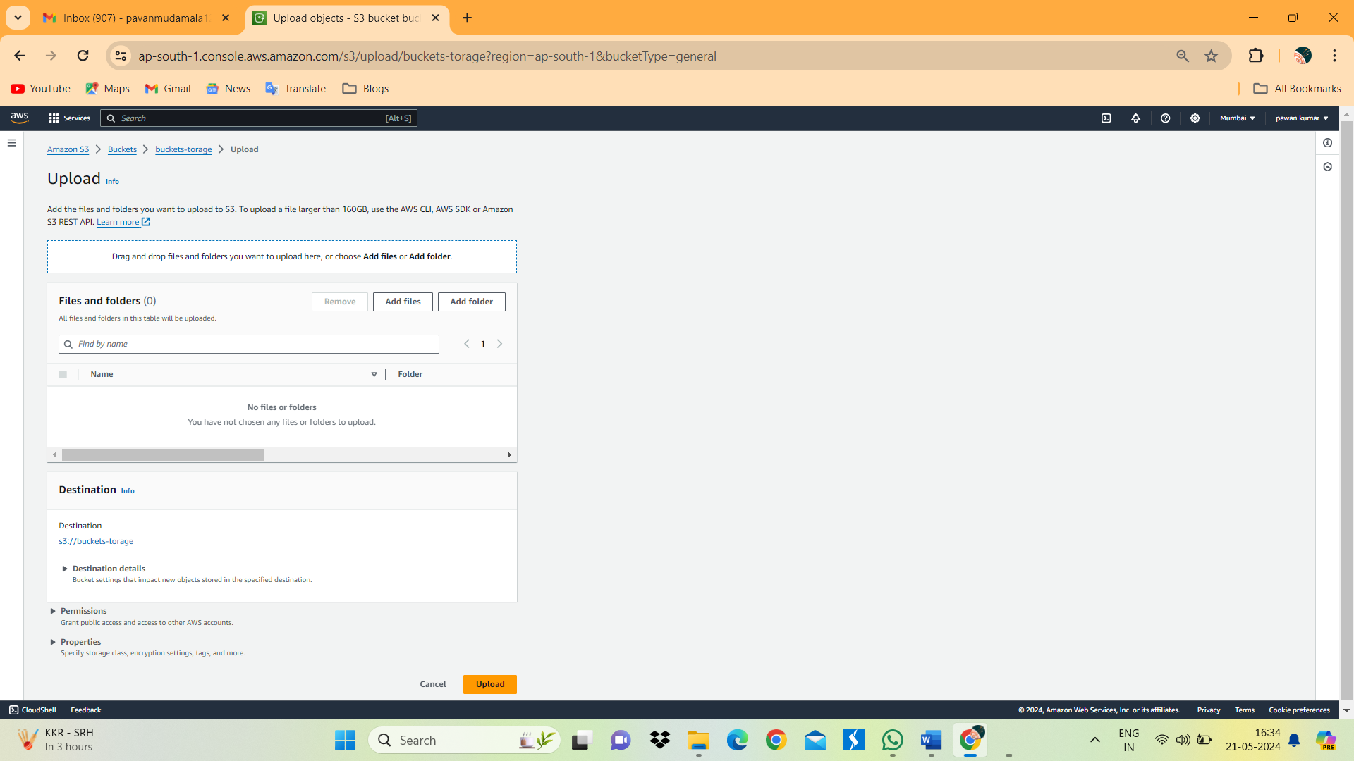

1. Choose the file which we want to upload in bucket-storage

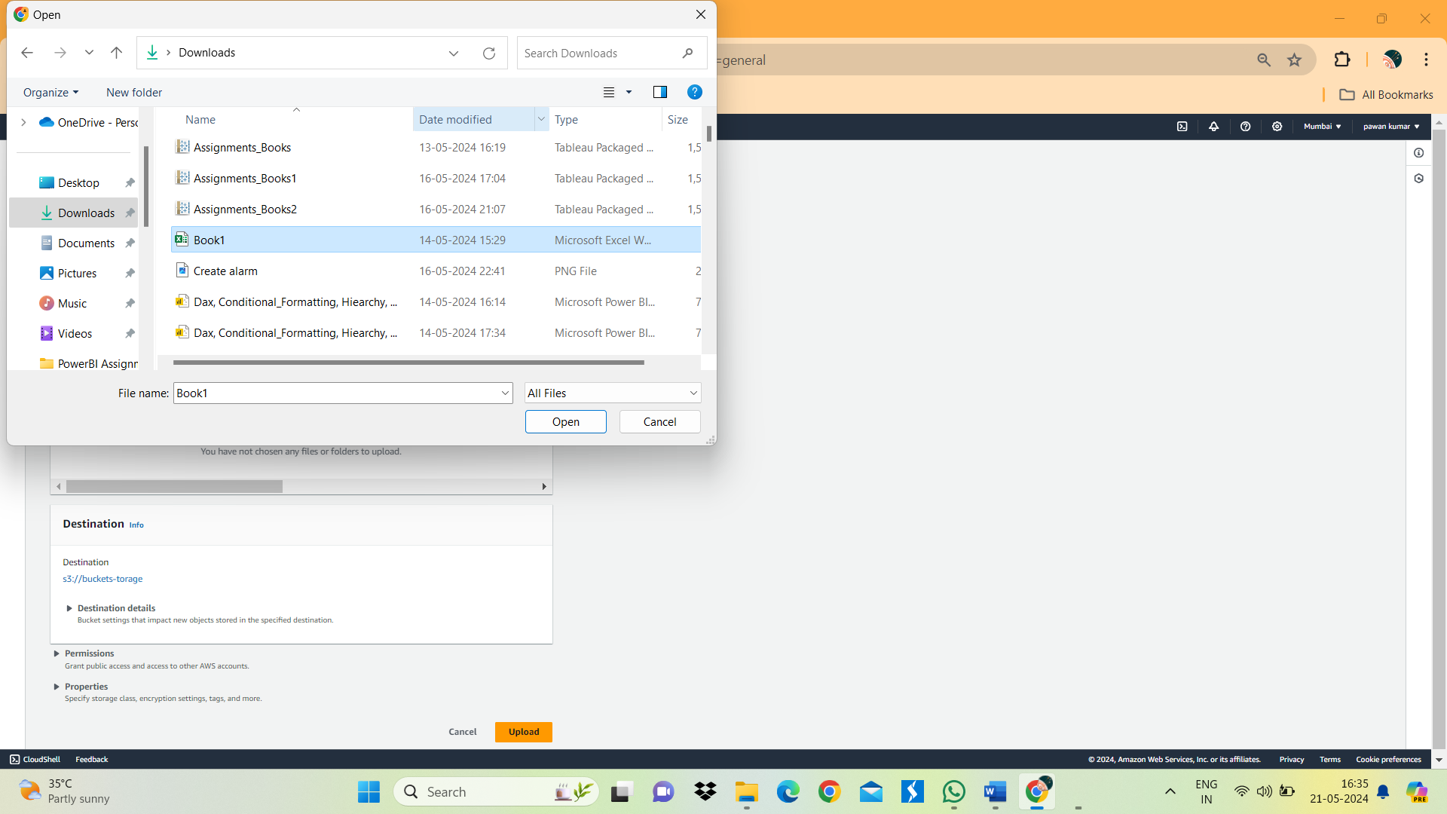

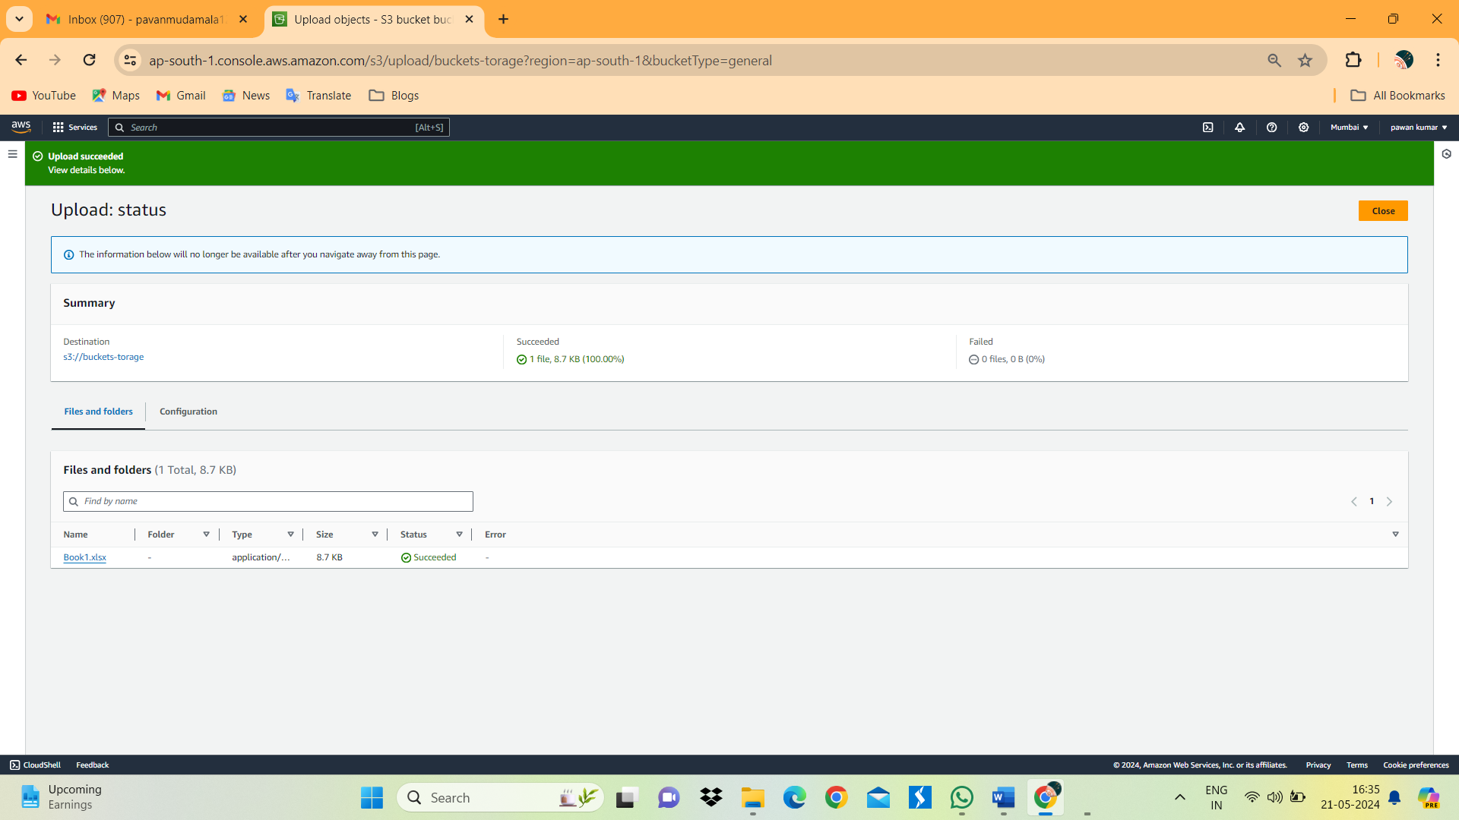

1. Above image we can see the sattus of uploaded file.
2. Click on download option on left side top to download a file.

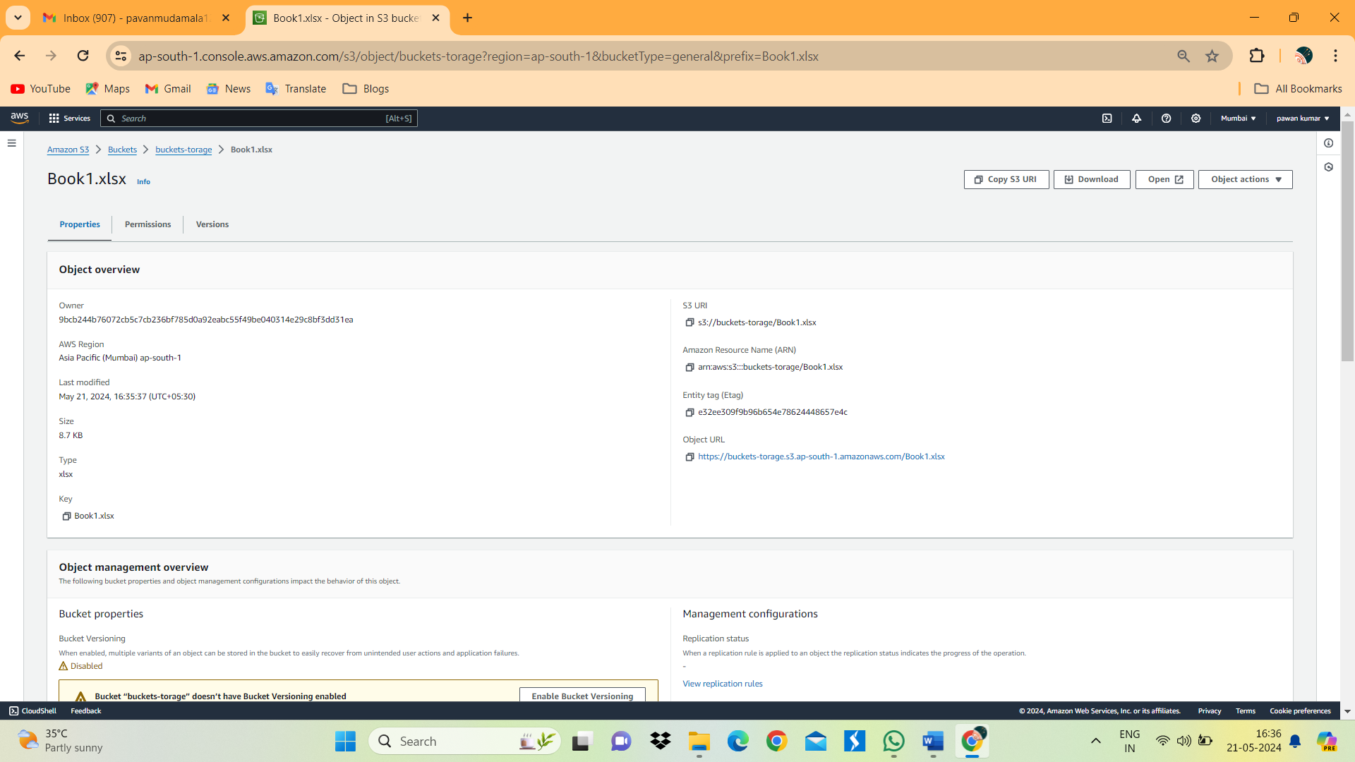

1. We can see the status of downloaded file.

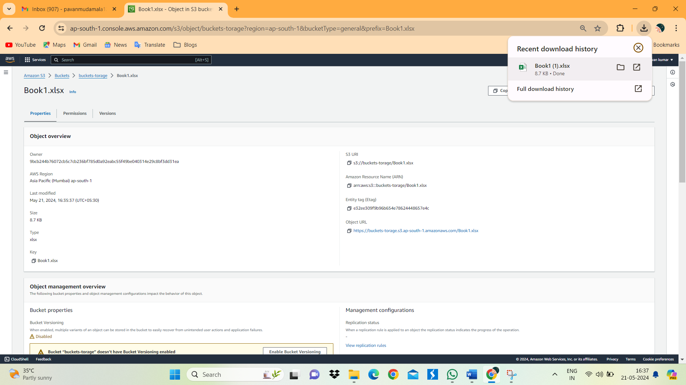

10.click on Create Folder.

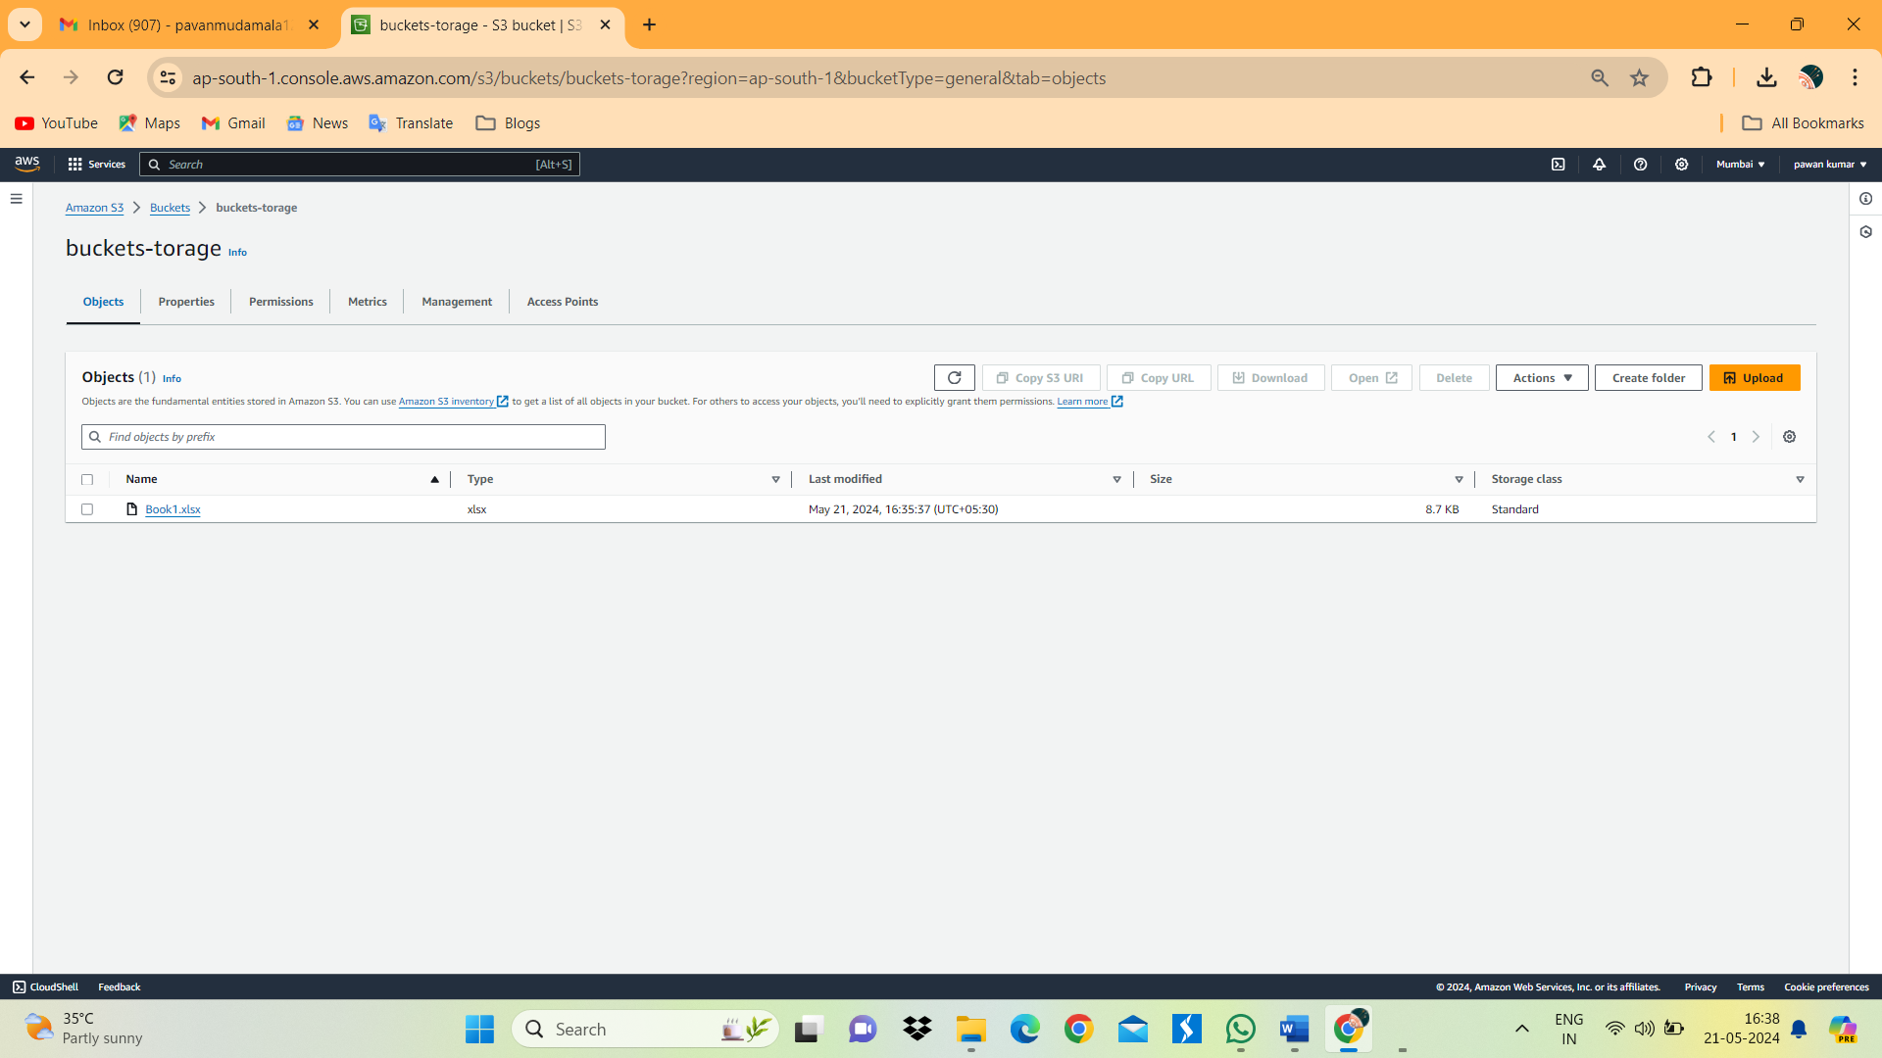

11.Give the name for folder in S3bucket.

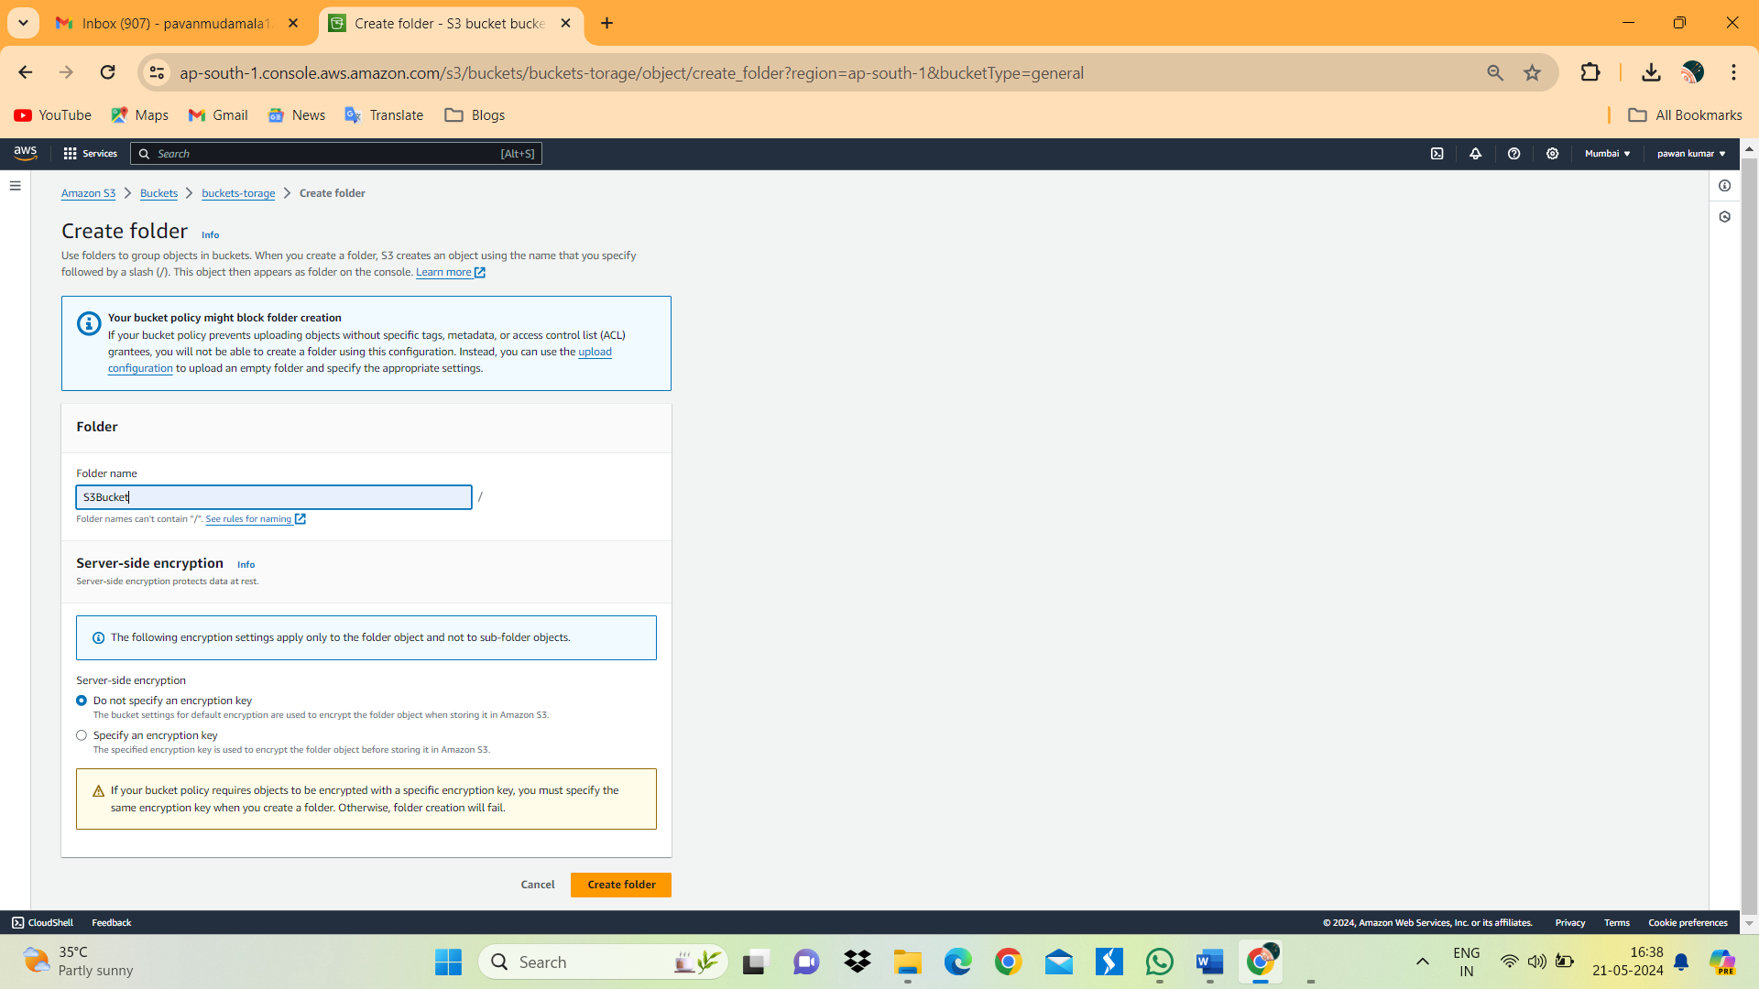

12. Below image we can see the folder S3Bucket.

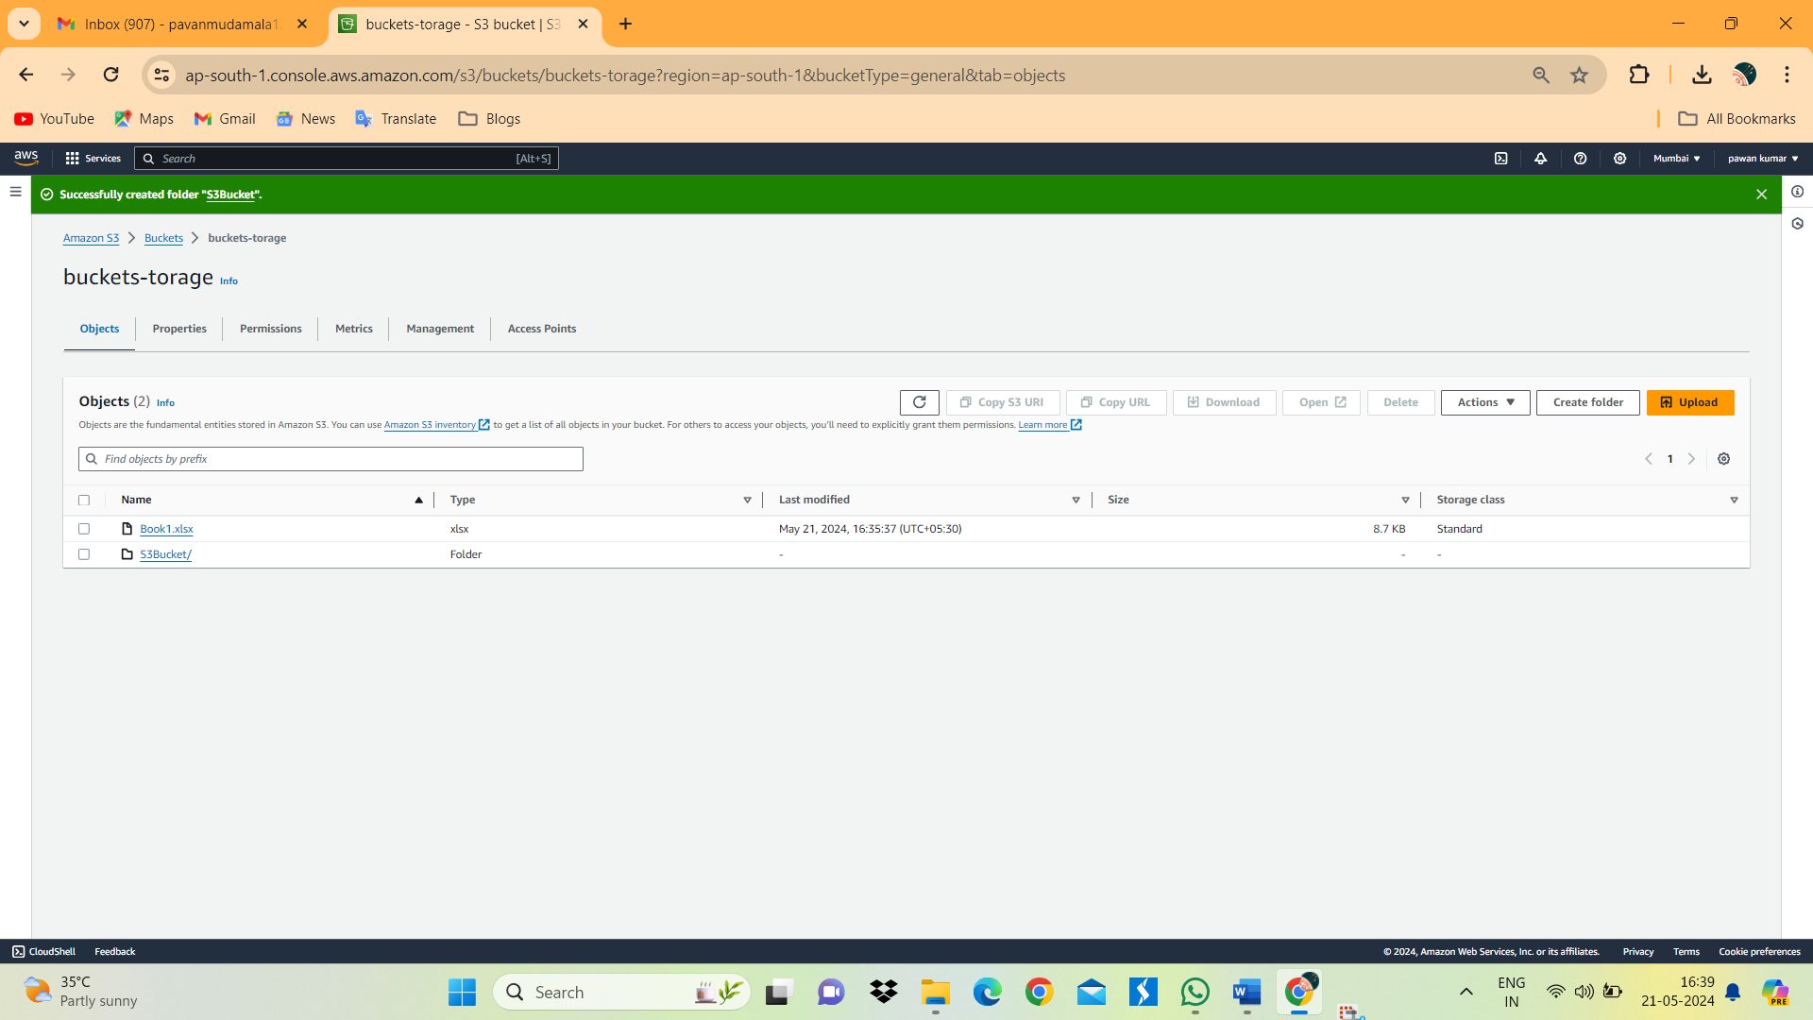

13. click on file which we want to copy to folder.

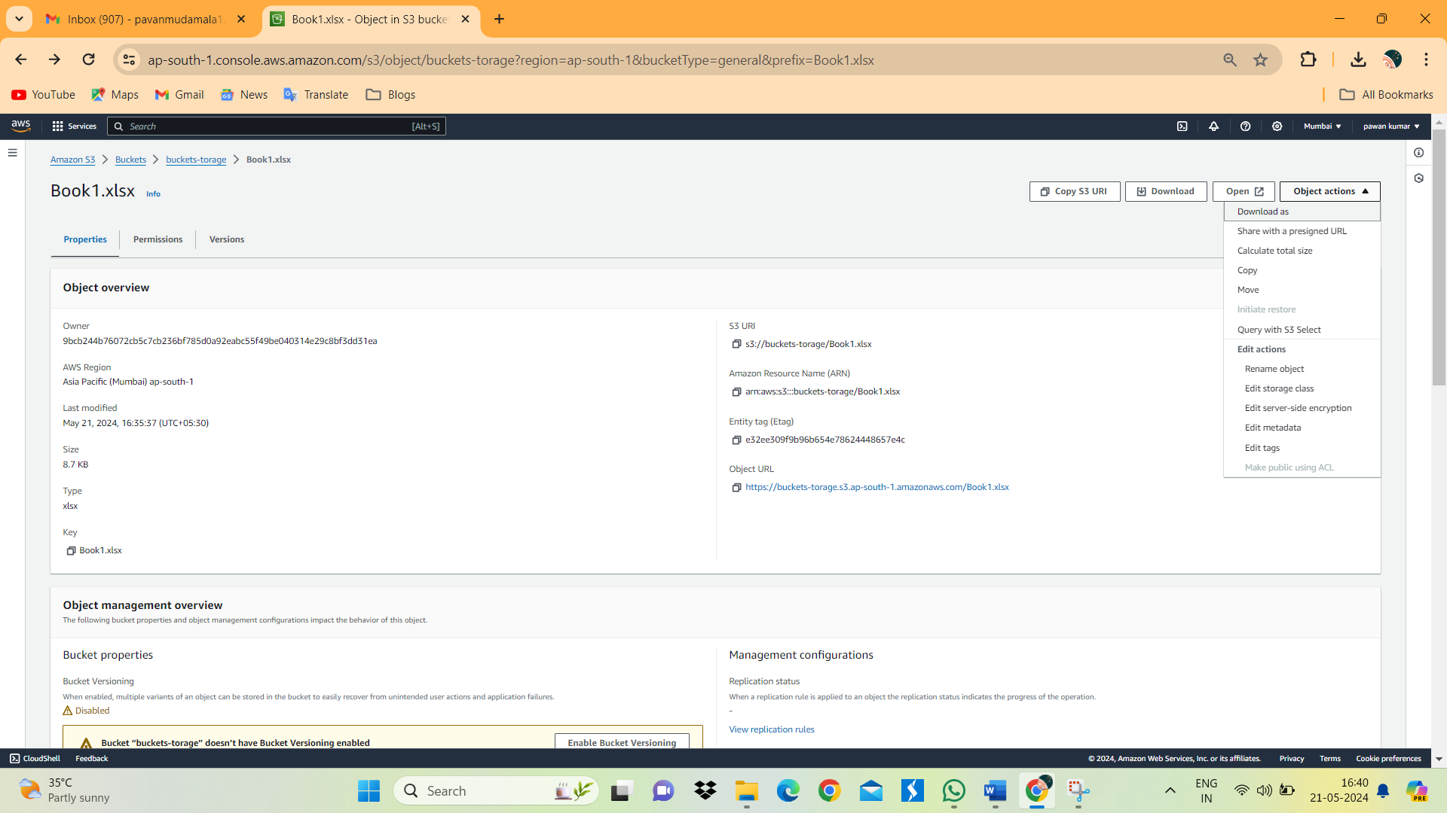

14. Click on Browse S3.

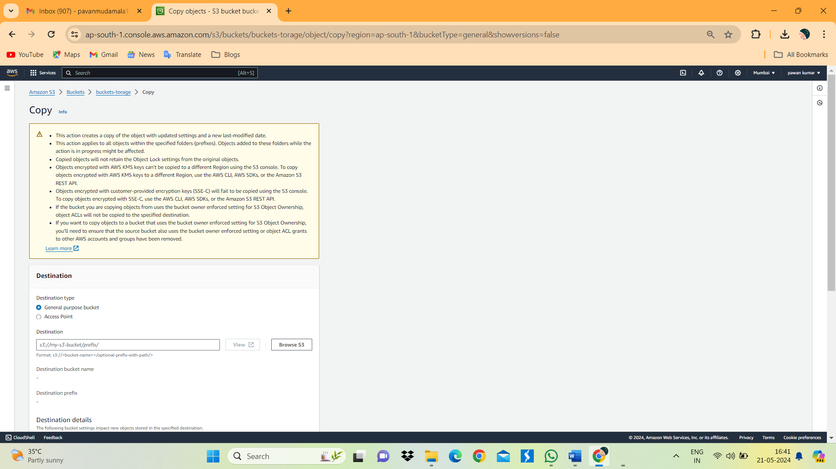

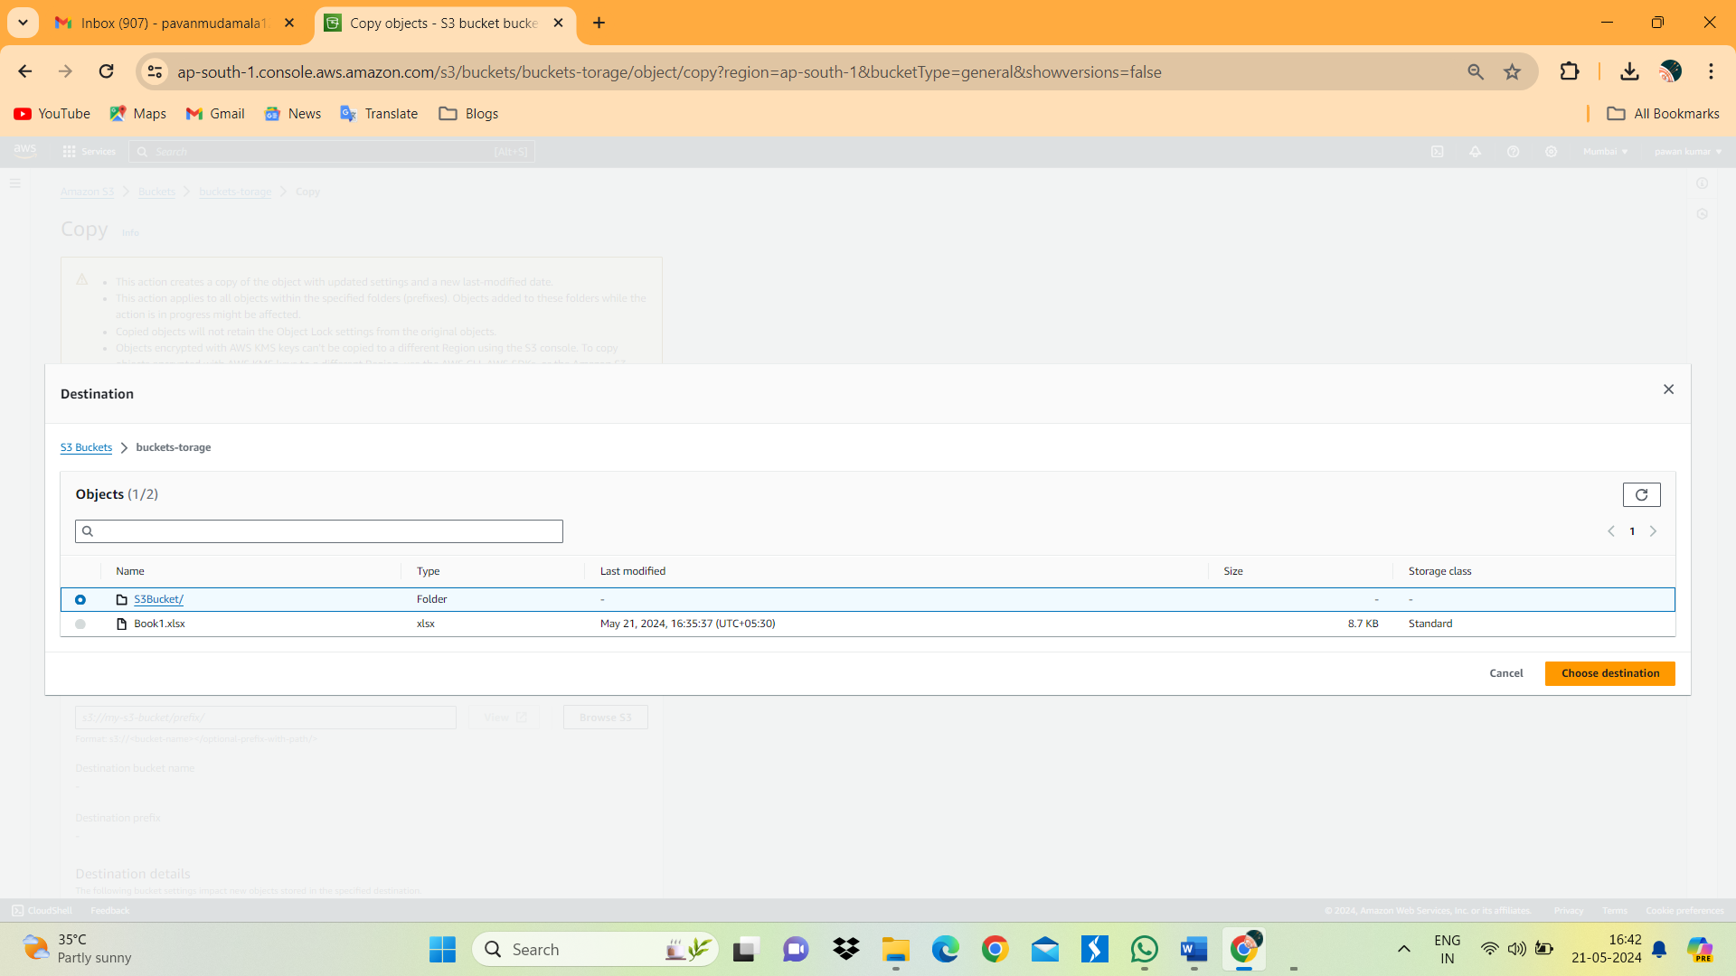

15. Select folder S3Bucket and click on choose destination.

16.Finally click on copy.

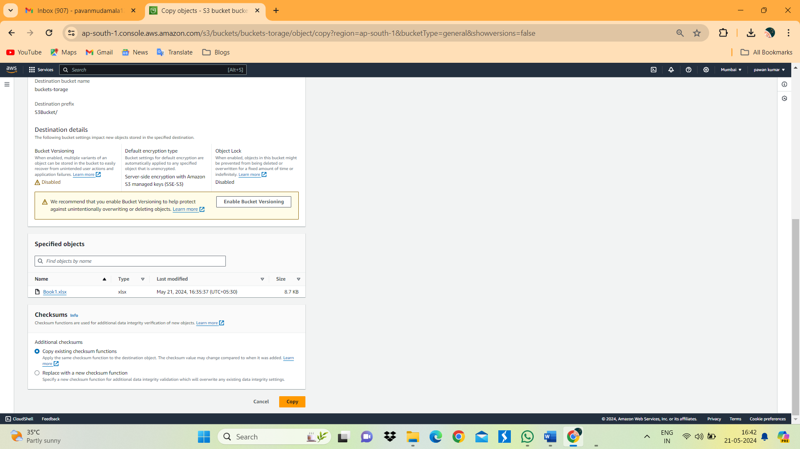

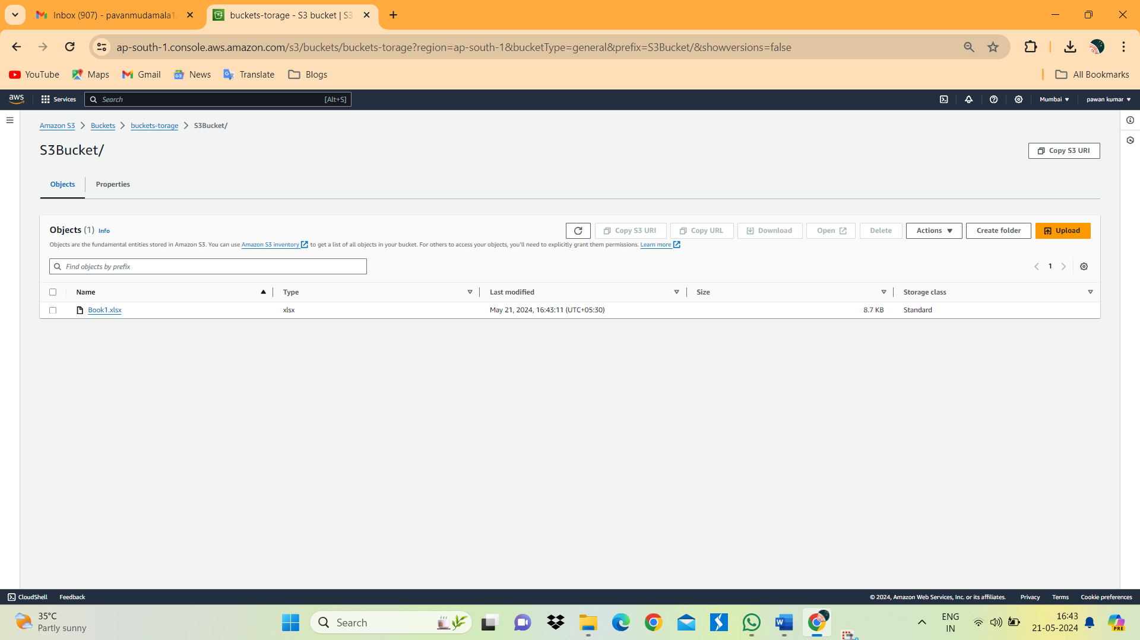

17. we can see S3Bucket folder the file has copied.

18. Back into S3 bucket select file whisch we want to delete.

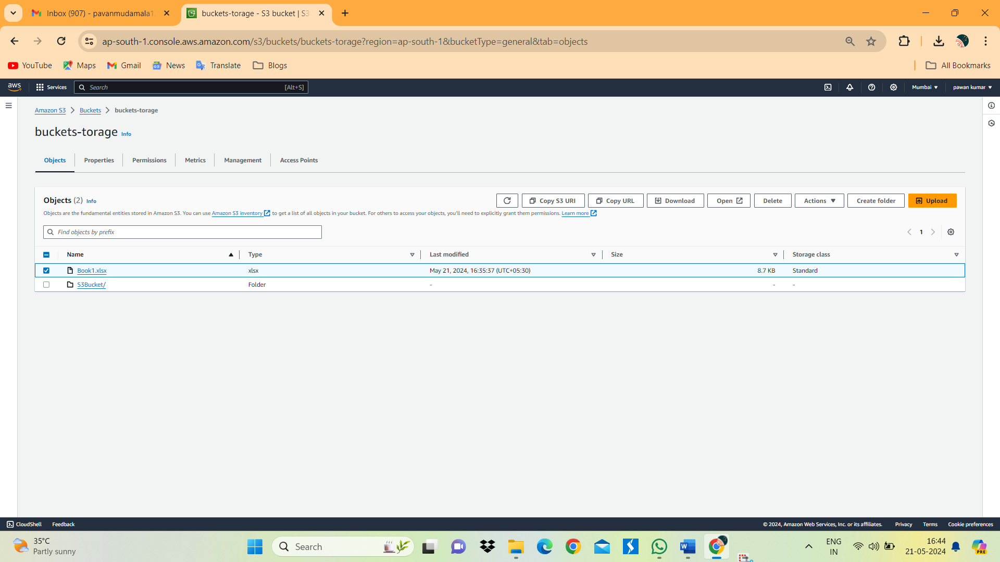

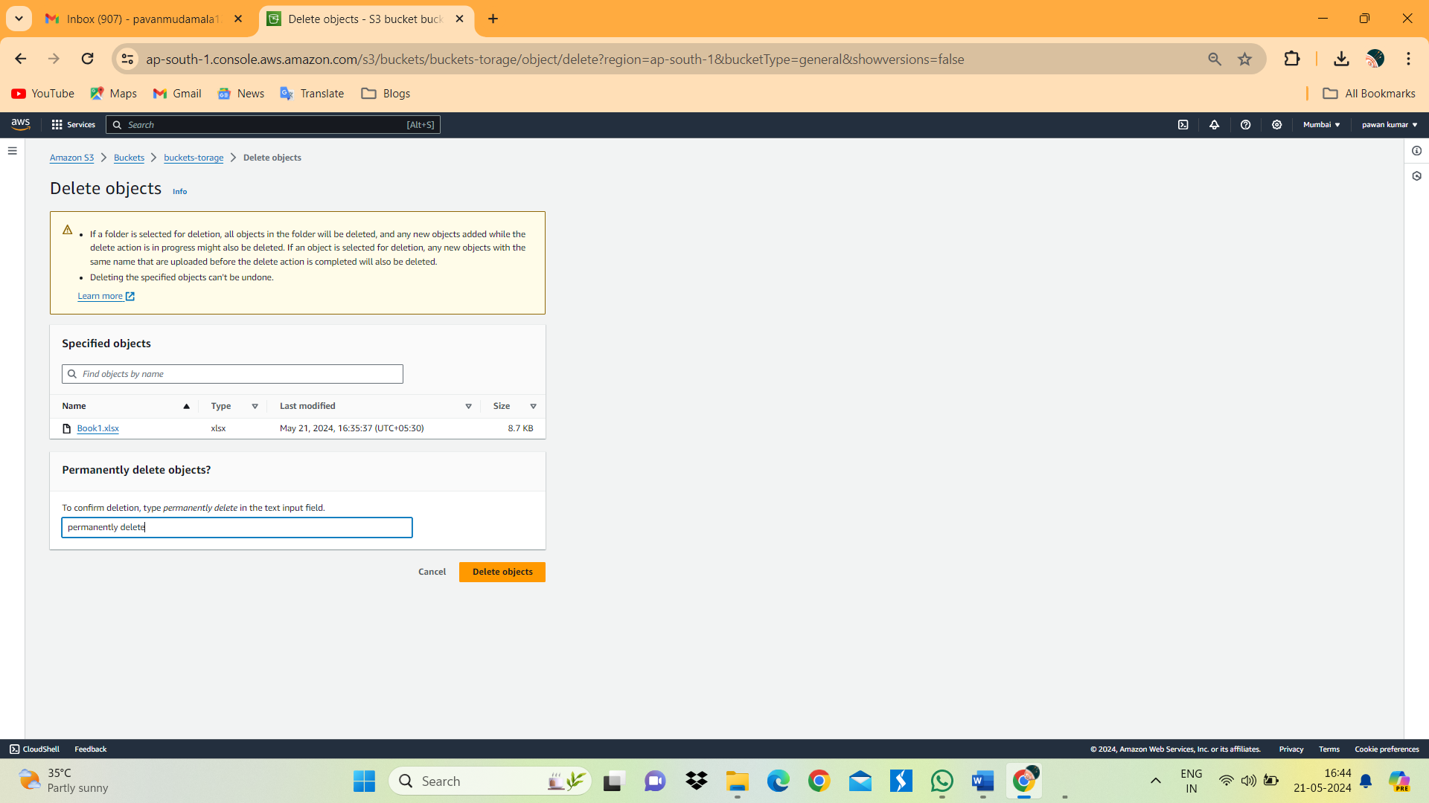

19. Type permanently delete and click on delete Object.

20. Same way we can delete folder as well.

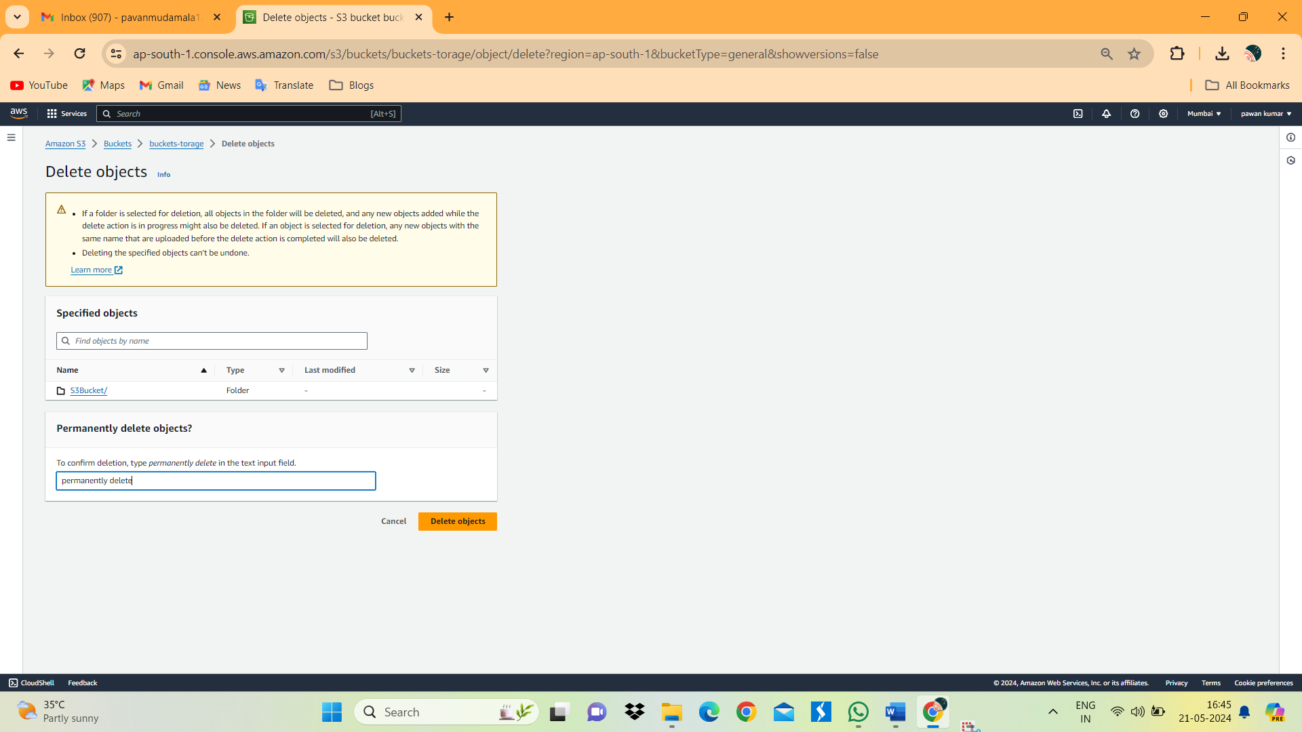

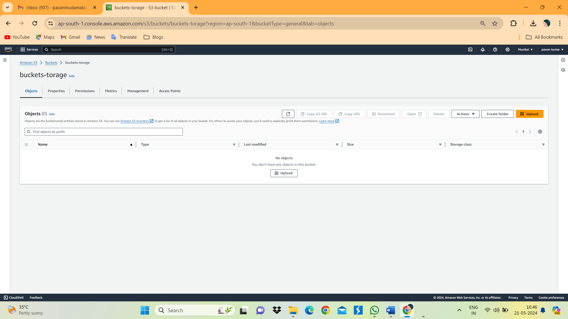

21. we can see above image folder and file has been deleted.